Impact of Benchmarking and Transparency Ordinances on stakeholder interactions and building energy efficiency

PHD Proposal

Committee:
Prof. Erica Cochran-Hameen, PhD, LEED AP, AIA, NOMA – Committee Chair
School of Architecture, Carnegie Mellon University

Prof. Vivian Loftness, FAIA, LEED AP
University Professor, Paul Mellon Professor, Andrew Mellon Professor
School of Architecture, Carnegie Mellon University

Prof. Berangere Lartigue, PhD
Associate Professor,
Paul Sabatier University, Toulouse, France

Contents
Abstract 5
Introduction 6
Context 7
1. Buildings and wasted energy 7
2. Consumers and awareness of energy use 9
3. Opportunities for Energy efficiency investment 9
4. Origins of building benchmarking and transparency policies 10
5. Who benefits from the data transparency? 11
Research 13
1. Research gaps 13
2. Research hypotheses 15
3. H1: increase key stakeholders interactions 16
4. H2 : increased overall Energy Efficiency initiatives 23
5. H3 : increased energy efficiency 29
Deliverables 33
References 34

Table of Figures

Figure 1: Energy Intensity Index by end-use sector.(DOE 2012) 8
Figure 2: the Drawdown, list of building related solutions 9
Figure 3: McKinsey evaluation of Market opportunity for Energy Service Companies (ESCO) 10
Figure 4: maps of cities with benchmarking ordinance (IMT, 2018) 12
Figure 5: Proposed methodology for identifying the impact of benchmarking and transparency ordinances 16
Figure 6 : Importance of involving various stakeholders in the design of a benchmarking and transparency ordinance 19
Table Figure 7: timeline of benchmarking process 20
Figure 8: timeline of how Cambridge followed Boston’s effort to develop and implement a benchmarking ordinance 22
Figure 9 square footage covered by voluntary effort compared to an ordinance 27
Figure 10 Durations of various energy competitions and enactement of a benchmarking ordinance. 28
Figure 11: Best practices developed by Energy Data Accelerators partners 29
Figure 12: growth of the Energystar Database 32
Figure 13: growth of ENERGYSTAR buildings in New York City and Houston. 33
Figure 14: Research timeline of benchmarking ordinances impacts 34

Table of Tables

Table 1: Landmark literature on value of benchmarking and transparency ordinance 15
Table 2: stakeholder groups that provided insight through interview, working group and meetings 18
Table 3: Main Stakeholders involved in the benchmarking policy design and implementation process 18
Table 4: Document produce through these interactions 23
Table 5: Participation in a urban network of cities with benchmarking ordinances 26
Table 6: number of buildings and their average score per year since 2007 in ENERGYSTAR database 33

Abstract

In the past decade, US Cities have been taking an increasingly important role in addressing climate change. This commitment often takes the form of a climate action plan. These climate action plans vary in their level of details of implementation, however they all set aggressive targets for carbon emission reduction at the local level by 2030 or 2050, through changes in energy, transportation, food and waste management. This research evaluates the effectiveness of benchmarking ordinances in 26 US cities and their ability to meet the recommendations the International Panel of Climate Change (IPCC) .

The urban building stock has an active role to play in preventing global warming as buildings use 40% of the US total energy and are responsible for the vast majority of carbon emissions, reaching 70% in New York City and 80% in Pittsburgh, PA (EIA 2012a) (City of New York 2018) (City of Pittsburgh 2018). Implementing building efficiency retrofit and design solutions is a major step to reduce carbon emissions and have a significant impact.

To evaluate the effectiveness of benchmarking and transparency ordinances, the research hypotheses that benchmarking ordinances increase communication among stakeholders, lead to more energy efficiency initiatives and programs, and facilitate reduced energy consumption in in commercial buildings.

The methodology comprises interviews with over 60 stakeholder groups including, federal agencies, local governments, non profits organizations, and utility companies; the creation and the statistical analysis of a wholistic data set on local energy efficiency initiatives -including policies, voluntary programs, and networks-; and quantification of energy consumption changes that occured after the establishment of benchmarking and transparency ordinances.

The findings of this research will establish quantified benefits that cities with existing benchmarking and transparency ordinances can utilize to justify their climate action plan. Additionally, it creates a roadmap for meeting climate action and energy efficiency goals for cities considering benchmarking and transparency ordinances.

Introduction

Building scientists know that buildings use 40% of the energy in the US (EIA 2018). There are many research efforts in material improvements, design solutions and advanced technical solutions to improve buildings, but the market penetrations of new solutions remains slow and most buildings are still ran inefficiently and without control systems (EPA 2012). In the late 2000’s , several US municipal governments decided to spark interest and trigger investment in low performing buildings by mandating large buildings to share their energy use publicly. The theory, based on other market transformation efforts, was that this transparency would lead to more accountability and market awareness which in turn would entice investment in energy efficiency (Burr 2012).
The first cities to implement this concept discovered that energy data access was very challenging as the existing utility data management systems were not design to provide whole-building data access. This barrier necessitated numerous interactions among local stakeholders to identify and design adequate solutions. The volume of work and the avoidable pitfalls led pioneering cities to share their lessons learned abundantly with others interested in the process through organized networks and working groups in a manner rarely seen before.
This research will first highlights the intricacies of the implementations of benchmarking ordinances and how they created a high volume of new interactions among stakeholders at different scales. Then the correlation between this increased knowledge transfer and the momentum toward sustainability and energy efficiency efforts will be evaluated.
Finally, the benefits of benchmarking ordinances with regard to energy efficiency improvements will be evaluated by comparing for the first time, the change in ENERGYSTAR score, in cities with benchmarking ordinances before and after the first deadline of the ordinances as well as compared to a control group without a benchmarking mandate.

Context

Buildings and wasted energy
In 1990, the IPCC established internationally in its first report that reduction of energy use in existing commercial buildings was needed to reduce carbon emission. The report also states that a 50% reduction was technically feasible with existing technologies in 1990. However it would require involvement of governments, institutions and consumers to achieve the needed market level penetration to prevent climate change (IPCC,1990).
Shortly after, the U.S. Environmental Protection Agency (EPA) released a voluntary tool to track energy usage, where building managers would enter their energy bills and the tool would track over time and compare to peers by attributing an ENERGYSTAR score when possible. This tool is the ENERGYSTAR Portfolio Manager and has been available over 30 years. It now contains over 450,000 buildings representing almost 50% of the US square footage of commercial buildings.(EPA 2016)
While this tool has been available in addition to other privately developed tools, and the rest of the economy became more efficient; the commercial sector continued to be more inefficient every year until the early 2000’s as illustrated in figure 1 (DOE 2012).
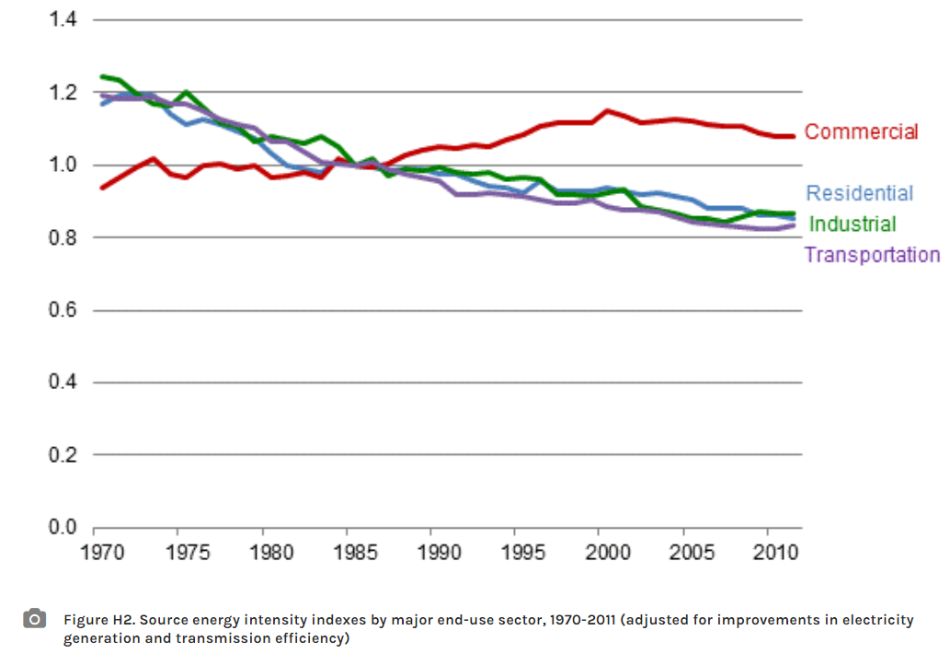
Figure 1: Energy Intensity Index by end-use sector.(DOE 2012)
The Energy intensity index eventually plateaued and recently started to slightly decrease but is still 11% more inefficient than in 1970.
The lack of gain in efficiency can be partially explained by the ever-growing electric load on buildings and higher expectation from the public on thermal comfort. The building industry never actively countered this increased loads with new technology adoption at a massive enough scale.
In 2002, Mazria and the Architecture 2030 think-tank established an incremental pathway for the existing building stock to be part of the solution to reduce carbon emission by 2030 (Mazria 2002). They developed annual goals for new and existing buildings, which set progressive yet aggressive energy use reduction targets to achieve over the years in order to meet carbon emission reduction targets by 2030.
Architecture 2030’s simple plan accelerated the realization among policy makers and the building communities that aggressively reducing energy use from existing buildings was a realistic and actionable solution to get the carbon reduction needed to avoid a dramatic shift in earth climate. As a consequence, several 2030 districts have burgeoned throughout the US. These districts organize buildings located in the same area with the objective of identifying adapted solutions to meet these goals and supporting each others. While the number of districts is growing, the participation is not nearly enough to have the impact needed.
More recently, Hawken released “Drawdown, the most comprehensive plan to fight climate change” which list the 100 solutions with the biggest impact to address climate change. This plan encompass all the fields that can contribute to drawing down carbon emissions. Ten solutions detailed in the book involve the building stock as listed in figure 2. According to this plan, implementation of building related solution would reduce CO2 emissions by 54.5 gigatons (Hawken 2017).
BUILDING AUTOMATION – through controls and sensors, automation systems turn appliances and other energy uses on and off according to need and use, increasing utilization and reducing space heating and cooling waste.
GREEN ROOFS (cool roofs and green roofs) – cool roofs reflect solar radiation and reduce air temperature, which leads to reduction in cooling loads. Green roofs have a similar effect as well as reducing heating loads in regions of high heat demand. Collectively, green roofs mitigate carbon emissions by reducing fossil fuel use in heating and cooling.
HEAT PUMPS – high efficiency heat pump systems are radically more efficient than conventional HVAC systems. The use of heat pumps reduces building heating and cooling loads.
INSULATION – insulating building envelopes reduces space heating and cooling loads, which in turn mitigates carbon emissions.
LED LIGHTING (COMMERCIAL) – replacing conventional lighting solutions (bulbs, ballasts and systems) with more efficient commercial light-emitting diodes.
LED LIGHTING (HOUSEHOLD) – replacing conventional lighting solutions (bulbs) with more efficient household light-emitting diodes.
NET ZERO BUILDINGS – not counted/calculated - composite
RETROFITTING – not counted/calculated – composite
SMART GLASS – specially designed glass that can be implemented in buildings to control the infiltration and emissions of solar radiation, leading to reductions in space heating and cooling loads which, in turn, mitigate carbon emissions.
SMART THERMOSTATS – internet-connected devices in households that reduce the heating and cooling demand of homes by using sensors and intelligent settings to maintain building comfort.
Additionally, Project Drawdown modeled another key solution that depends on and interacts with buildings, but is categorized in the Energy Sector.
SOLAR HOT WATER – the use of solar radiation to pre-heat or heat water for residential and commercial use within buildings, which reduces the need for conventional fossil fuel- based water heating.
Figure 2: the Drawdown, list of building related solutions

Consumers and awareness of energy use
In addition to existing technologies capable of reducing energy waste. We know that consumers can also drive the reduction. Research has shown that consumers change their behavior to save energy when receiving feedback about it, both athome or at work. A study showed a 7% energy use by household with in home display thermostat (Faruqui, Sergici, and Sharif 2010). In the work environment, research project from the Center for Buildings Performance and Diagnotics measured 9% energy savings from a group of employees receiving feedback on their energy consumption.
However , only 100M out of 117M household have smart thermostats and only 14% of commercial buildings had a BAS systems in 2012 during the most recent CBECS survey (EIA 2012). Giving energy information to a greater audience could possible lead to greater savings.

Opportunities for Energy efficiency investment
The McKinsey group released a study of the potential market for energy service companies (ESCO) as illustrated in figure 3.
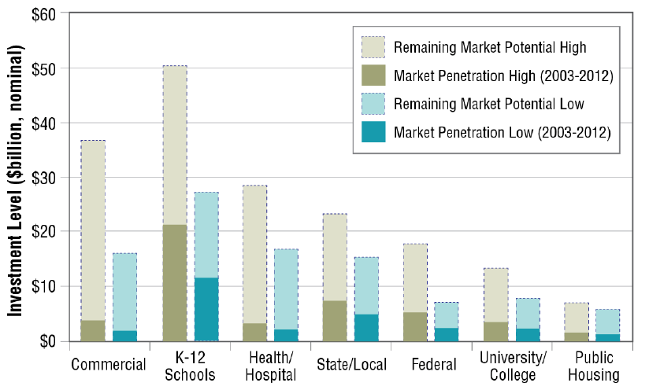
Figure 3: McKinsey evaluation of Market opportunity for Energy Service Companies (ESCO)
In the study, they concluded that the market was over $35 billion of investment opportunities and that over 80% of the market was still untouched (McKinsey & Company 2010) .
Addressing these opportunities is what will make the building sector meet its role in energy use reduction. But the demand is not sufficient. While the market exists, the investment decisions are not being made because of lack of prioritization of energy performance.

Origins of building benchmarking and transparency policies
The need to act locally to address climate change became more pressing in light of the difficulties to develop and execute an international solution during COP meetings. More and more cities created task forces and working groups to develop municipal climate action plans. Those plans set aggressive goals for the horizons. While developing these plans, tackling energy use in buildings became more evident at the local scale as buildings are responsible for 70-80% of Carbon emissions in urban setting (City of New York 2007) (City of Pittsburgh 2018). Understanding how these buildings used energy to develop policies and program to address their waste became a necessity and benchmarking and transparency ordinances are perceived as the first steps toward this understanding.
Building Benchmarking refers to annual tracking of the energy use of a building to compare it to its peers, a standard or its past performance (EnergyStar 2015). The concept of benchmarking energy in buildings has been present in the building industry since early 1990’s according to Perez.(Pérez-Lombard et al. 2009).
A building benchmarking ordinance, is a mandate by a city or county, requiring property owners to reports their energy --and some times water use to the local government. The local government will then make the data public in various formats such as a visual map of performance, a report, a public dataset. The ordinance is applicable to a specific type of buildings over a certain size threshold defined in the ordinance and varying by cities. For instance, in Pittsburgh, non-residential buildings over 50,000sqft have to report their energy and water use to the city since June 2018. This concept is recent and was introduce in an American city for the first time in 2008.
Ordinances are thought to force broader adoption of the benchmarking tools and create awareness of energy waste. This new awareness would drive the market toward investing in efficiency for buildings to remain competitive and attract tenants (Hart 2018) .
Cities also intend to use the information to inform policy design and programs that will support local adoption of energy efficiency measures(Shah et al. 2016).
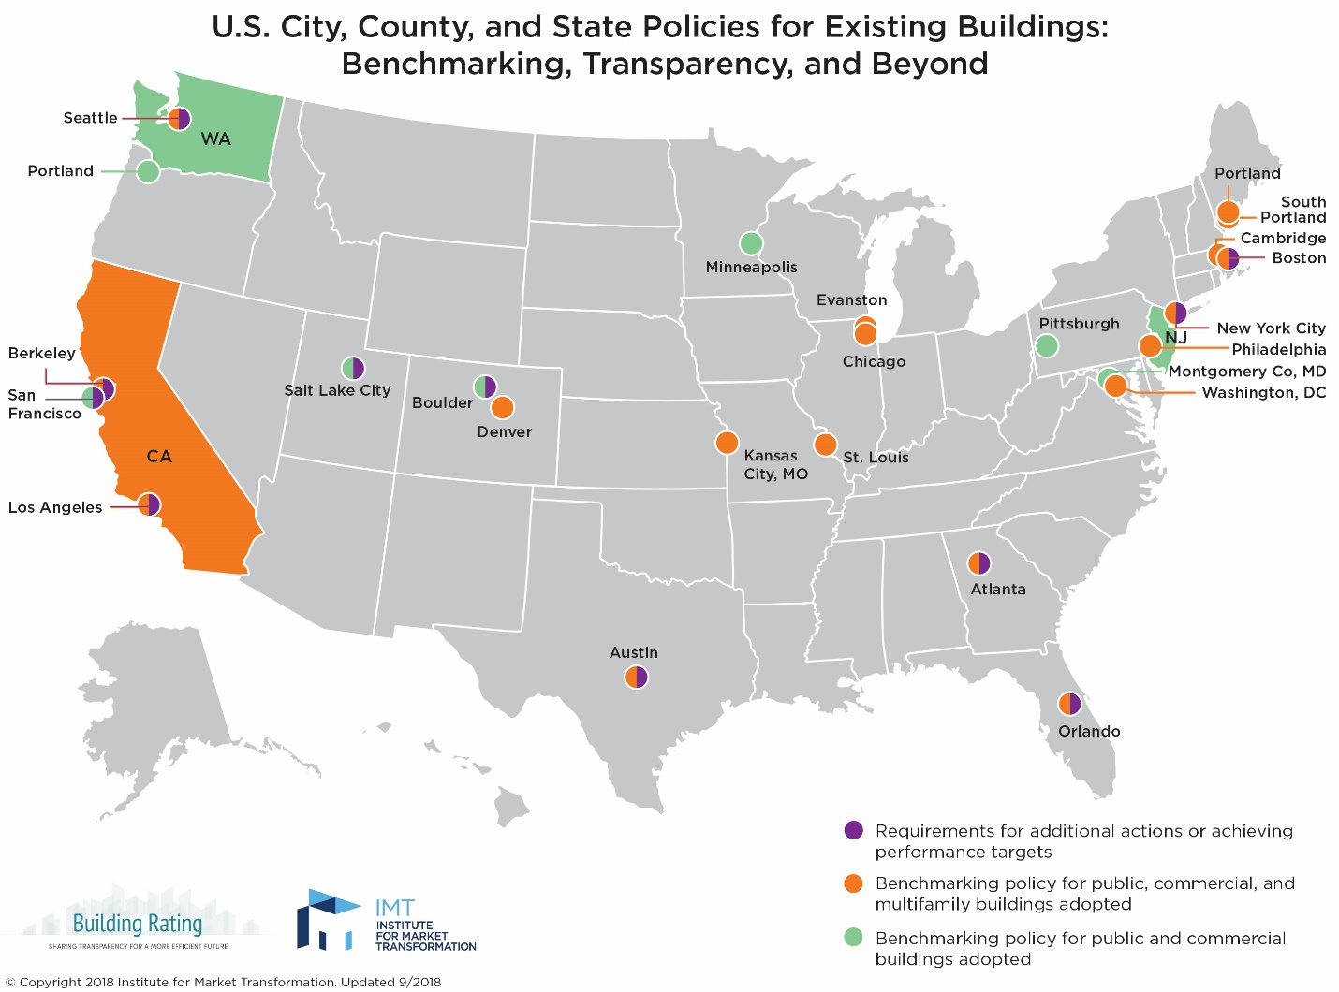
Figure 4: maps of cities with benchmarking ordinance (IMT, 2018)

Who benefits from the data transparency?

Benefits to Owners:
Building benchmarking benefits many stakeholders: The first stakeholders that can leverage information from benchmarking are the owners: First, comparing to peers helps understand whether a building is wasting energy and could be run differently or improved to save energy and money(EPA 2012).
Secondly it allows to compare against past energy use to identify sudden change in consumption or confirm that upgrade of system indeed provided the expected savings.
Lastly, a building performing well can use the information to attract high quality tenants.

Benefits to Utilities
Many stakeholders saw immediate applicability of benchmarking data to assist utilities programs. Most utilities are required to distribute rebate programs by their Public Utility Commission(PUC). The recruiting of the consumers benefitting from these rebates varies by utilities and often the rebates are distributed on a first come first serve basis and not on a most needed basis(Palmer and Walls 2014). Benchmarking energy use offers a reference to prioritize buildings which would benefits the most from upgrading their systems (Krukowski 2014) . However, the number of utilities using public benchmarking data or private benchmarking data is still low.
Benchmarking data can help identify locally what buildings owners should invest in to improve their energy performance. This can help craft local program that would invest funds where they are the most needed, based on real local data and not national data or assumptions. (Krukowski 2014)
Finally Benchmarking can be a supplemental data set to traditional evaluation methods (Krukowski 2014).

Benefit to Cities:
More and more cities are completing a Green house gas emission inventories and building benchmarking information can be used to estimate local emission from the building stock.
Benchmarking provide new insight in the quality, age and potential issue of the local building stock. This data can help tailor policy to support the local building stock to become more energy efficient (Krukowski 2014).

Benefit to Tenants:
A study conducted by the Costar group revealed that tenants are willing to pay more to occupy LEED or ENERGYSTAR buildings and value spaces where their utilities can be lowered (Fuerst and McAllister 2009). Transparency about energy use can assist them in deciding what building to select when searching the real estate market for a new space.

Research

Research gaps
Despite many reports, guides and lessons learned published since 2008, there is very little quantification of the impact of benchmarking ordinances and their value.
During our participation in the Energy Data Accelerator, we collected evidence that benchmarking ordinance were creating a dialogue that generated best practices for governments and utilities (Shah et al. 2016).
The deliberations around benchmarking seemed to have created a momentum that lead to additional efforts toward energy efficiency but there is no documentations of the link between benchmarking ordinances and increased policy and energy efficiency initiatives.
The most used argument to justify mandating benchmarking is a percentage of savings calculated by EPA based on voluntary benchmarking. Their analysis showed that when continuously benchmarking over 3 years or more, building owners would see an average of 2.4% of energy savings(EPA 2012). This number is based on building owners willfully participating in a benchmarking process and does not include both the mandatory and the transparency component of the ordinance.
Only 2 studies used a control group to compare the impact of such ordinances on the building stock. The first one was conducted on the benchmarking dataset of New York, NY. The date showed a 6% reduction after 3 years and a 14 % reduction in EUI after 4 years of policy implementation (Meng, Hsu, and Han 2017) . The second study looked at utility expenditure in a Real Estate fiduciary association database and identified a reduction of 3% in utility expenditure. (Palmer and Walls 2014). Other quantifiers are percentage of actions taken based on survey of building owners and utility customers(NEMA 2017) (NMR group 2012).
Regularly, non-profits such as local regional Energy efficiency organizations creates a overview report with updated recommendation best on the benchmarking process in new cities, but those do not contains new analysis (NEEP 2013) (Coleman and Kauffman 2014). Cities published their progress and these reports provide an interesting incite in the success of the policies but this report do not offer a control groups to compare with (DOE 2015) (Mims et al. 2017)
There is no other available attempt to analyze the impact of benchmarking ordinances across American cities. My dissertation will provide an additional analysis to complement this 3 quantifying analyses.

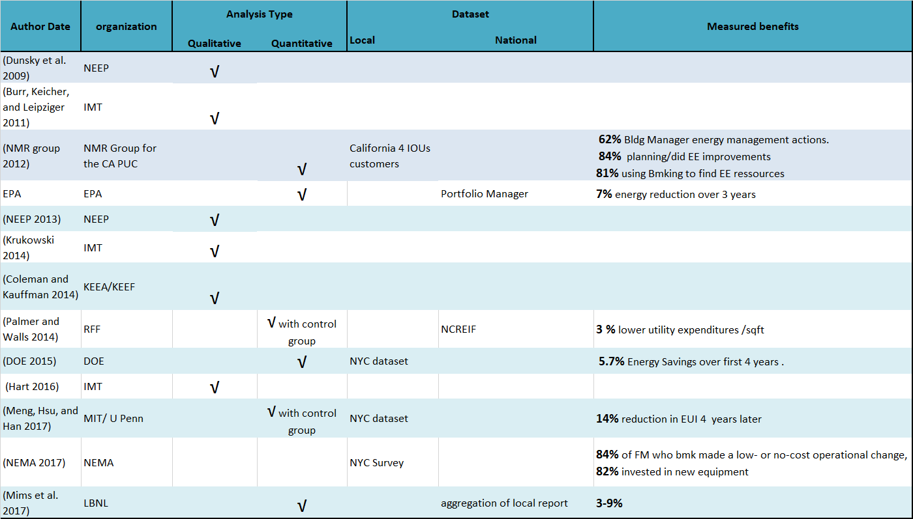
Table 1: Landmark literature on value of benchmarking and transparency ordinance

Research hypotheses

As established in the first section of the proposal, a benchmarking and transparency ordinance is often the first action with regards to addressing the local building stock inefficiency through policy. A complex communication process ensues between various stakeholders on the topic of energy data and the value added by benchmarking and transparency requirements.
The intent of this research is to quantify the benefits of benchmarking ordinances by exploring the following 3 ypotheses.

Hypothesis 1:
Benchmarking and transparency ordinances created new and numerous interactions across interest groups about energy and built environment.

Hypothesis 2:
This high level of discussion and information exchange among stakeholders participated in augmenting awareness and initiatives on sustainability and energy efficiency locally.

Hypothesis 3:
Benchmarking ordinance correlated with increased energy efficiency in buildings covered by the mandate.
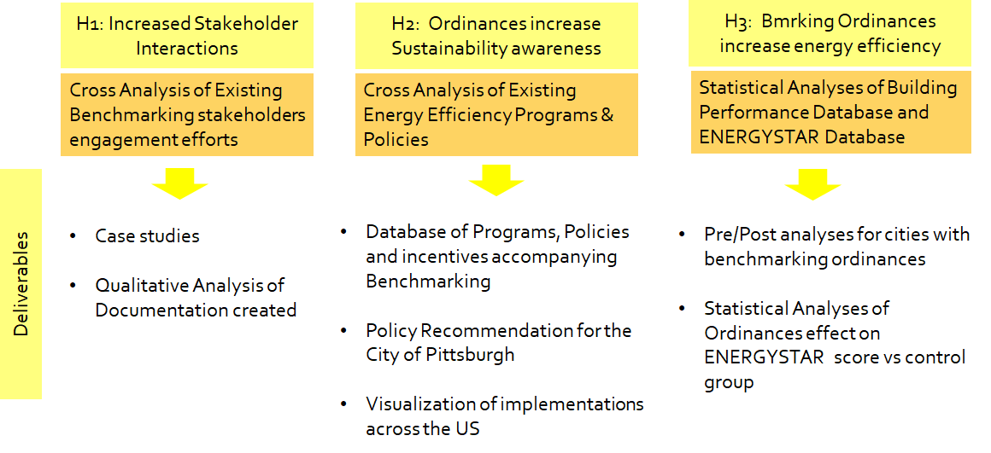
Figure 5: Proposed methodology for identifying the impact of benchmarking and transparency ordinances

H1: increased key stakeholders interactions

Benchmarking and transparency ordinances increased key stakeholders interactions across interest groups about energy and built environment.

Methodology:
Interviews, workshop and discussions with experts have fueled the research to address this first hypothesis. We have engaged the 60 stakeholder groups listed in table 2 to establish how the stakeholder process happened locally and nationally.
Cities |  | Utilities | Federal Agencies | Non profits | Universities / Labs | Consultants
Atlanta, GA | Des Moines, IA | AEP Ohio | EPA | IMT | University of Pennsylvania | ICF
Boston, MA | Fort Collins, CO | Atlanta Gas Light (AGL) | DOE | DVGBC | Penn State | DNV-GL
Austin, TX | Miami-Dade,FL | Austin Energy |  | GBA | MIT
Cambridge, MA | New Orleans, LO | Commonwealth Edison (ComEd) |  | NRDC | NREL
Chicago, IL | Pittsburgh, PA | Kansas City Power & Light (KCP&L)
Chula Vista, CA | Providence, MA | Los Angeles Department of Water and Power
Columbus, OH | Reno, NV | National Grid
District of Columbia | San Jose, CA | NSTAR/Northeastern Utilities
Houston, TX | St Louis, MO | Orlando Utilities Commission
Kansas City, MO | St-Paul, MN | Pacific Gas and Electric Company
Los Angeles, CA |  | PECO
Minneapolis, MN |  | Pepco
New York, NY |  | Puget Sound Energy (PSE)
Orlando, FL |  | Questar Gas
Philadelphia, PA |  | Reliant/NRG
Salt Lake City, UT |  | Rocky Mountain Power
San Diego, CA |  | San Diego Gas & Electric (SDG&E)
San Francisco, CA |  | Southern California Edison
Santa Monica, CA |  | Southern California Gas
Seattle, WA |  | Xcel Energy
30 |  | 20 | 2 | 4 | 4 | 2
Table 2: stakeholder groups that provided insight through interview, working group and meetings
Sample questions to local government:
“Q2. Did any particular stakeholder group establish themselves as a leader, a convener, or in any way take a more active role than other participants?”

Results:
The stakeholders involved in the various cities are listed in table 3. The table is a sample of the stakeholders engaged in the cities listed. Feedback was provided from other cities for aggregated use only.
City | Utility | USGBC | REEO | Owners Assoc. | Large Owners | Universities
Seattle | V
DC | V
Philadelphia | V | V |  |  | V | V
Boston | V |  |  |  | V | V
Cambridge | V |  |  |  | V | V
Chicago | V | V | V |  | V
Salt Lake City | V |  |  | V | V

Table 3: Main Stakeholders involved in the benchmarking policy design and implementation process
Energy benchmarking at a city scale created a discussion among actors that did not used to work together.
Findings: Cities who passed benchmarking ordinance earlier engage solely their utilities before passing an ordinance. Cities who passed ordinances later have engaged a broader audience before enacting an ordinances.

Participation level of stakeholders

The interviews revealed the best practices in term of level of engagement and importance of engagements of various stakeholder illustrated in figure 6.
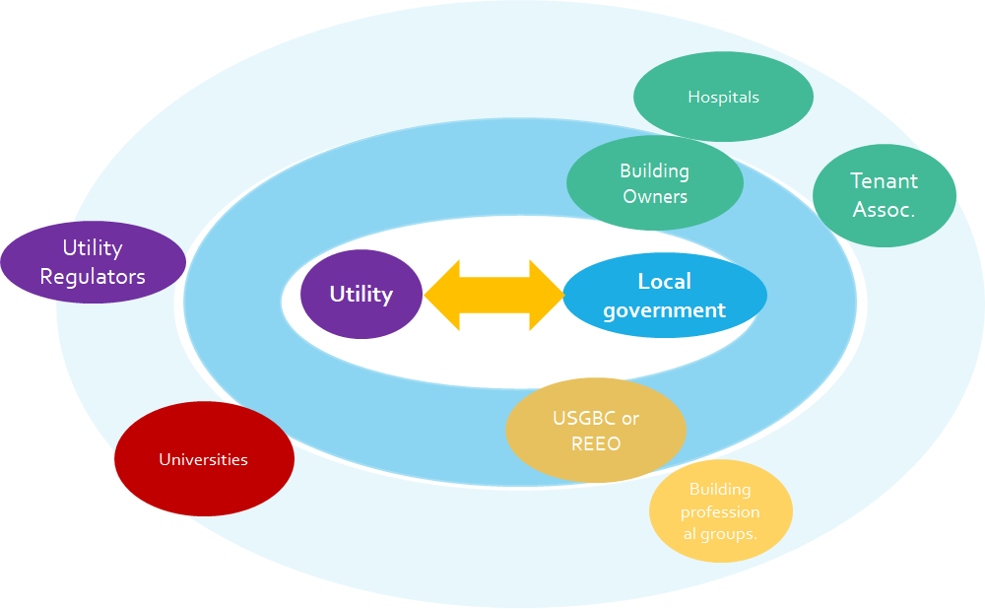
Figure 6 : Importance of involving various stakeholders in the design of a benchmarking and transparency ordinance
The interviews revealed that engaging with local utilities early on was essential to ensuring success and high compliance rate.
Secondly, building owners should be brought in the discussion early in the design of the benchmarking ordinance, so they can provide valuable feedback on tailoring the requirement to the local market and to make sure they understand the goals of the ordinance and do not perceive it as “another duty“ imposed by the local government.
If the region benefits from a strong presence of a local USGBC chapter, a Regional Energy Efficiency Organization or another relevant non profit, they should be involved early on in the process. They can provide critical support with their knowledge of the market and their existing network will help reach out to a wide audience for outreach and trainings.
Findings:
- Engaging with the Utility prior setting up compliance deadlines is primordial to make sure the data access is enable to make to process straightforward for building owners.
- Involving Building Owners representatives during the design of the ordinance create a better dymamic and stronger supports for the enactment of the ordinance.

Timelines of benchmarking and transparency implementation

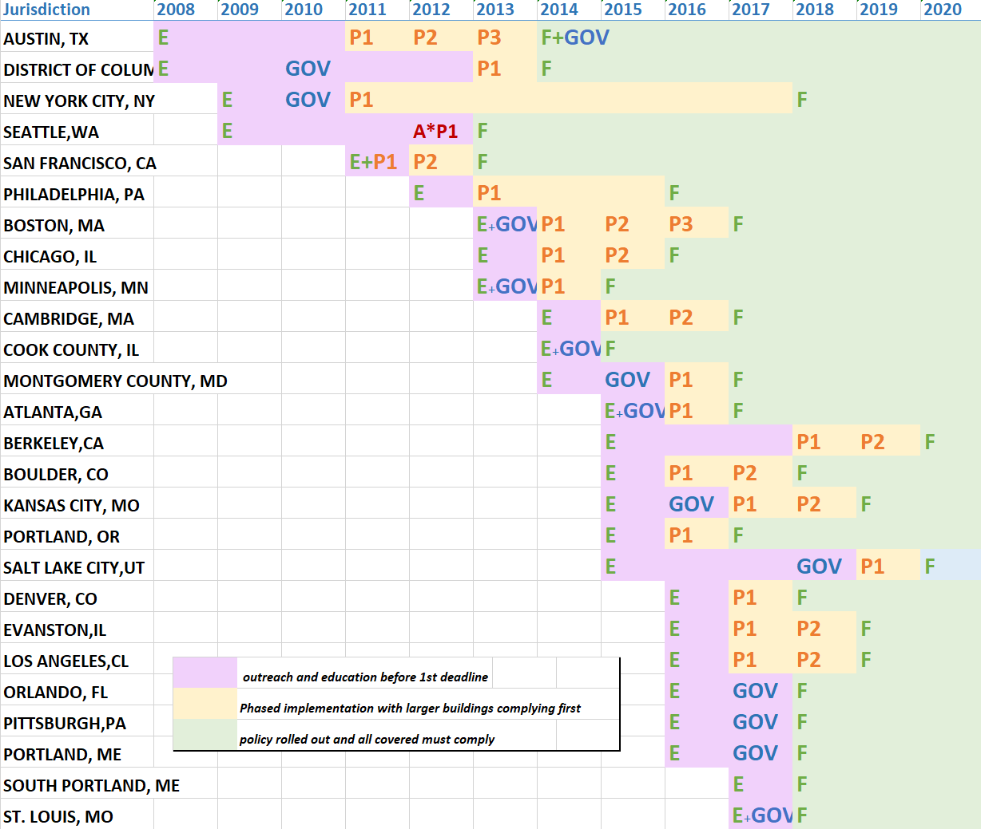Table Figure 7: timeline of benchmarking process
This overview of the implementation timeline reveals that pioneering cities as a longer lag between enacting the ordinance and the first deadline. Most cities voting ordinance later on had a shorter timeframe between the enactment and the first reporting deadline.

First Generation of benchmarking Ordinances:
In Washington, DC the government passed the ordinance in 2008 then realized that data access was going to be problematic as property owners were required to access data directly from the tenants, including for Multi-family buildings(Duer Balkind 2015). This resulted in low compliance from the multi-tenant properties and the District realized there was a need for engaging both energy utilities, to resolve the implementation challenges and simplify the process. The city engaged both the electric and gas utility companies, and after conversations with them, decided to amend the Clean Affordable Energy Act to implement data access as requirement from the utilities in order to improve the process.
In Austin,TX the benchmarking ordinance was passed as a direct follow up of the climate action plan. The local municipal utility is leading the benchmarking energy data collection effort. The ordinance was adopted for commercial buildings in 2008 and amended several time after to expend its scope to residential and multi-family.
In New York, NY the Local Law 84, part of the Greener, Greater Building Plan was passed in 2009 and was one of the recommendation of the Green Codes Task Force. Many stakeholders were involved while not having an effort specifically around energy benchmarking for buildings before passing the ordinance. The Real Estate Association was involved in the Greener Greater Building plan since 2006 and so were many commercial building owners ( 2014, Donna Hope). The first compliance deadline was in 2010 for public buildings and 2011 for private buildings. PLANYC 2011 announce the creation of a resource for building owners to provide them with tools to benchmark and implement energy efficiency measure. This resource will become Building Energy Exchange (BEEX) officially launch in 2015.
In Seattle, WA the benchmarking ordinance was one of the conclusion of the Green task force, knowing that the State mandated utilities to maintain a record of energy consumption data of all non residential and qualifying public agency (Antonoff and BALLINGER 2014). The utilities were task to develop the IT solutions on their own. While there were initial talk to have one common portal, they all ended up developing their unique solutions. In light of the situations, the city engaged with the utilities in many discussion to amend the ordinance to require whole building data access within a realistic timeline for the utilities to provide the necessary solution. The utilities offer aggregated “whole-building” energy data for owners needing to comply with Seattle’s ordinance and/or for their own energy management purposes. The meter consumption data is directly uploaded on a monthly basis to the owner’s Portfolio Account via the “data exchange” web service. Seattle helped the utilities to determine the most feasible, cost effective ways to provide the data and promote the services to their customers. Regional utilities that city of Seattle partnered with were: Seattle city lights, Puget Sound Energy and Seattle steam. The utilities also agreed to help inform their customers of the Seattle requirement by providing website links and phone referrals to Seattle’s Energy Benchmarking Help Desk(Ballinger 2013).

Second Generation of benchmarking Ordinance
This Cities pursued their stakeholder engagement effort BEFORE passing the ordinances which resulted in less amendment and quicker timelines of implementation. Can you show it?
In Philadelphia, PA after five cities established a benchmarking ordinance, the need to engage a broader audience became more apparent. Philadelphia was able to use the lessons learned from those cities to identify data access as a key factor for success. To address data access issues, Philadelphia asked the CBEI (formerly EEBhub) to act as a convener and a technical advisor for the utilities to bring them on board and successfully implement data access before the first reporting deadline. The city chose to mandate data access in the ordinance but working out the details on the side(Monisha Shah 2015).
Philadelphia city government chose to engage high level representatives from key stakeholder groups to participate in a series of working group and convening sessions. These convening sessions facilitated a fast decision making and buy-in process.
Boston, MA followed a unique implementation model by tackling the issue in reverse order compared to the first cities enacting benchmarking and transparency ordinances; they worked with utilities to put the concerns of data access to rest before enactment the benchmarking ordinance. The electric utility then had a staff in the city of Boston’s office to work directly with the team implementing the ordinance to ensure optimal collaboration and a streamlined effort for building owners.
In Chicago, IL, the utility ComEd has been providing aggregated data and webservices to Portfolio Manager since 2008 before the Benchmarking Ordinance was even discussed and many building owners were already taking advantage of the utility tool, EUDS. The time frame between the passage of the ordinance and the first deadline was only 9 months, one of the shortest of all. The outreach effort focused on trainings and 16 sessions were organized by ComEd, People’s gas and EPA to make sure people knew how to report. The utilities were supportive of the creation of the benchmarking ordinance (Ponce and Bricknell 2014).

Regional stakeholder interactions

In addition, to increased local discussions on opportunities and barriers surrounding energy benchmarking implementation, a regional effect can be observed. Several Cities who voted an ordinance in the past 5 years are located in the proximity of a municipality that had already enacted or implemented a benchmarking ordinance. Interviews revealed that the proximity of another city facilitated the process on several levels as illustrated for the specific case of Boston and Cambridge in figure 8.
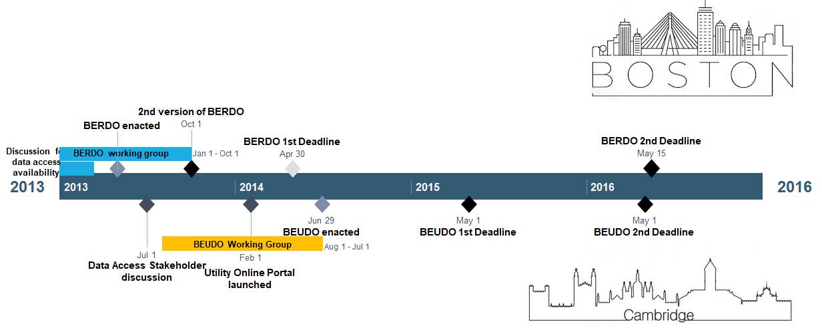Figure 8: timeline of how Cambridge followed Boston’s effort to develop and implement a benchmarking ordinance
In figure 8, we highlighted the parallel process between Boston and Cambridge
Large building owners who have properties in a cities with benchmarking ordinances were already educated about the process of complying with such ordinances and their concerns were addressed or appeased with the implementation in the first city as reported by city staff in Boston and Cambridge(Bolduc 2014).
When located in the same utility territory, the first city already provided a data access solution for their customers that is proven and tested by the first city as in the case with Evanston following Chicago(Monisha Shah 2015) .
In states where the Public Authority Commission had to modify the legal contact to enable whole data energy access, the first city in the state cleared the slate for the rest of the state, such as Pennsylvania where Philadelphia actively engage the PUC but Pittsburgh did not need to( Shah 2015).
Findings: city located near a location that previously passed an ordinance were able to have a faster process due to the outreach and local experience the first city created.

Resources as a result of the increase stakeholder interactions
With several cities going through the process of developing and implementing benchmarking and transparency ordinances, many resources were created to document and support the efforts, as we summarized in table 5.
audience | IMT | Better Building | Non-profits | Cities | Consultants | Academics
Local Government | 35 | 3 | 5 |  | 1 | 1
Utility | 23 | 6 | 2
Building Owners | 7 |  |  | 26
Regulator |  |  | 1 |  | 2
Everyone |  | 2 |  | 17 |  | 2
Total | 65 | 11 | 8 | 43 | 3 | 3
Table 4: Document produce through these interactions
The lesson learned through each implementation phases were documented in case studies or updated guidelines to facilitate the process for other cities. The benchmarking process generated over 130 documents, including the 10 national ressources that our team created for the better building.

H2 : increased overall Energy Efficiency initiatives

Benchmarking and Transparency ordinances build a momentum for energy efficiency and sustainability intitiatives.

After having shown that benchmarking increased engagements, I will explore if it participated in creating a momentum for energy efficiency, which had been lagging since the first year that IPCC stated the need for buildings to be better user of energy resources.

Methodology:

Data collection
We have collected information related to improving energy efficiency in 98 cities. These efforts include:
- voluntary programs for building owners such as 2030 district or Energy competitions with an energy reduction target over a set amount of time.
- Involvement: participation of the local government in a national or international networks for which energy efficiency is a focus such as City Energy Project, Urban Sustainability Director Network, International Council for Local Environmental Initiatives, C40, 100 resilient cities, American Cities Climate Challenge.
- Internal municipal goals of energy improvement on the cities owned facilities
- Policies : benchmarking transparency, retro-commissioning, auditing, lighting upgrade, etc
- Incentives for increased efficiency in new construction: zoning bonuses, fees waivers or discounts, expedite process, etc.
Currently 4,508 data points have been collected for this database which is build and expended upon information available in the DSIRE database from North Carolina Clean Energy center and funded by DOE.

Pre-post Analysis
This new dataset will be analyzed to evaluate if the participation or implementation of additional programs significantly correlated with enacting an ordinance.

Comparative Analysis
The number of initiatives will also be compared between cities with and without. Cities with benchmarking ordinance will be paired with similar American cities that have not yet passed an ordinance to find statistically significant differences correlated to the enactment of an ordinance.
For this analysis, cities can be paired according to the following criteria:
- Climate zone
- Age of the building stock
- GDP
- Population size
Additional factors to be considered for pairing are:
- Main economical driver
- Political leadership affiliation
- Average income
- Diversity ratio

Preliminary findings: Higher participation in national network
The following networks have been created to support benchmarking and transparency effort specifically or are a broader network with a working groups focusing on benchmarking.

2030 Districts
2030 districts are meeting incremental reduction targets for new and existing buildings set by the 2030 challenge for planning, which was issued by architecture 2030, a non-profit organization committed to transforming the built environment from a major contributor of greenhouse gas emissions to a central part of the climate crisis.
2030 Districts are led by the private sector, with local building industry leaders uniting around a shared vision for sustainability and economic growth, while aligning with local community groups and government to achieve significant energy, water, and emissions reductions within our commercial cores.

Better Building Energy Data Accelerator
The difficulties to collect whole building data led the Department of Energy to create the Better Building Energy Data accelerator announced on December 2013. Through the Better Buildings Energy Data Accelerator (EDA), local governments and utilities joined forces to make whole-building energy data access easier for building owners to benchmark their buildings. Over the span of two years, the experiences and best practices discussed and deployed by EDA Partners have been distilled into a toolkit of resources designed to guide local governments, utilities, and other stakeholders that may seek to design a whole-building data access solution in their jurisdictions.

ICLEI - Local Governments for Sustainability
ICLEI is the leading global network of 1,500+ cities, towns and regions committed to building a sustainable future.
Through this collective efforts, more than 25 percent of the global urban population.

City Energy Project
In parallel the non-profits Institute for Market Transformation and NRDC launched the City Energy Project in January 2014 with a funding of $10Millions to create healthier, more prosperous American cities by making buildings more energy efficient, boosting local economies and reducing harmful pollution. Support to implement benchmarking ordinances in the enrolled cities was one of the main component of the project. The city Energy Project provided 10 cities with a staff person and additional expertise to actively engaged all stakeholder involved to accelerate adoption of benchmarking ordinance by equipping the cities with the necessary knowledge to address the perceived barriers.

C40
Around the world, C40 Cities connects 96 of the world’s greatest cities to take bold climate action, leading the way towards a healthier and more sustainable future. Representing 700+ million citizens and one quarter of the global economy, mayors of the C40 cities are committed to delivering on the most ambitious goals of the Paris Agreement at the local level, as well as to cleaning the air we breathe

100 Resilient Cities
100 Resilient Cities (100RC) is dedicated to helping cities around the world become more resilient to the physical, social and economic challenges that are a growing part of the 21st century.

City | 2030/ Date launched | EDA | ICLEI | CEP | C40 | 100RC | energy benchmarking
LOS ANGELES | 2014 | √ | √ | 2014 | √ | √ | 2016 | 6
PHILADELPHIA | 2005 | √ | √ | 2014 | √ |  | 2012 | 5
ATLANTA |  | √ | √ | 2016 |  | √ | 2015 | 4
BOSTON |  | √ |  | 2014 | √ | √ | 2013 | 4
CHICAGO |  | √ |  | 2014 | √ | √ | 2013 | 4
NEW YORK CITY |  | √ | √ |  | √ | √ | 2009 | 4
PITTSBURGH | 2014 |  | √ | 2017 |  | √ | 2016 | 4
SAN FRANCISCO | 2014 | √ |  |  | √ | √ | 2011 | 4
DISTRICT OF COLUMBIA |  | √ |  | 2014 | √ | √ | 2008 | 4
AUSTIN | 2005 | √ |  |  | √ |  | 2008 | 3
DENVER | 2014 |  | √ | 2014 |  |  | 2016 | 3
MINNEAPOLIS |  | √ | √ |  |  | √ | 2013 | 3
BERKELEY |  |  | √ |  |  | √ | 2015 | 2
BOULDER |  |  | √ |  |  | √ | 2015 | 2
CAMBRIDGE |  | √ | √ |  |  |  | 2014 | 2
ORLANDO |  | √ |  | 2014 |  |  | 2016 | 2
SALT LAKE CITY |  | √ |  | 2014 |  |  | 2015 | 2
ST LOUIS |  |  |  | 2016 |  | √ | 2017 | 2
KANSAS CITY MO |  | √ |  |  |  |  | 2015 | 1
MONTGOMERY COUNTY |  |  | √ |  |  |  | 2014 | 1
PORTLAND |  |  | √ |  |  |  | 2015 | 1
PORTLAND, ME | 2017 |  |  |  |  |  | 2016 | 1
SOUTH PORTLAND, ME |  |  | √ |  |  |  | 2017 | 1
COOK COUNTY |  |  |  |  |  |  | 2014 | 0
EVANSTON |  |  |  |  |  |  | 2016 | 0
Table 5: Participation in urban networks of cities with benchmarking ordinances

Table 5 indicates the number of networks cities with benchmarking ordinances have joined. We can notice that most of them belong to at least one network, except Cook county and Evanston which are both in the vicinity of Chicago. This membership to several networks will be compared to other cities among other initiatives and conclusion will be drawn on the relationship between the mandate and the participations in relevant initiatives.

Overview of voluntary effort vs mandated benchmarking:
Several energy competitions have been run locally to motivate building owners to save energy.
A regular argument against a mandate is that building owners can benchmark their buildings on their own, and mandating it would not change their attitude ( Shah 2015). Figure 9 illustrates the square footage of buildings participating in voluntary effort in cities with an ordinance. It is contrasted to the square footage required to report their energy use to the municipality under an ordinance.

Figure 9 square footage covered by voluntary effort compared to an ordinance

As evident in figure 9, the area of buildings impacted by an ordinance is more important than participation in a voluntary effort. Consequently, an ordinance is more likely to increase the awareness of more building owners with regard to energy use than a voluntary effort.
Findings: Ordinances impact a much larger square footage of buildings than voluntary effort.

Duration of voluntary energy competitions
Several nergy competitions have been launched by local building owners and managers associations (BOMA) following competition models designed by BOMA such as the 7 points challenge or the kW crackdown. In other places, the competition is run by non-profit organizations using the Better Building framework or a point system developed in-house.
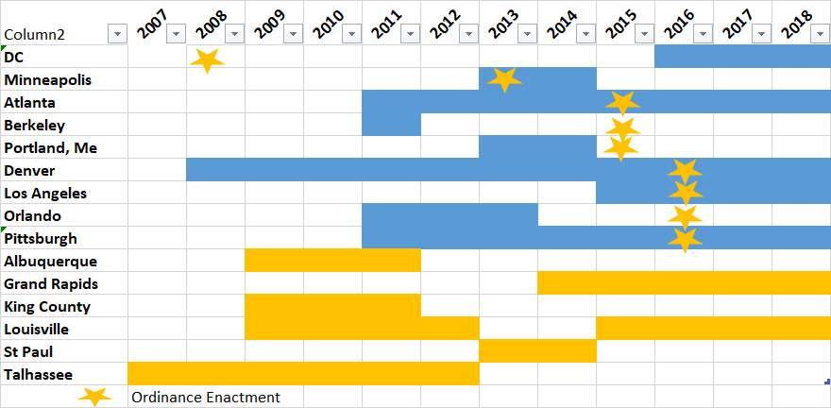
Figure 10 Durations of various energy competitions and enactement of a benchmarking ordinance.
There seems to be more on-going competitions in cities that have passed a benchmarking ordinance. Preliminary research indicates that energy competitions might be more successful in cities with ordinances. Additional research is needed to corroborates this observation.
There is evidence that several voluntary efforts have had trouble finding an active audience and did not last over time in places without an ordinance. In locations such as Salt Lake City and Orlando, voluntary effort were launched prior to considering an ordinances and were not successful. This lack of success motivated the local government to mandate benchmarking. Lehua Weaver, a Salt Lake City Budget & Policy Analyst described in a memo for city council supporting the benchmarking ordinance that the voluntary effort garnered participation from only 2% of commercial buidings.
“Participation in the existing voluntary program has not produced the desired results, and the ordinance would implement the program through a required participation”.
In Orlando, Only 25 buildings out 1800 signed-up ,achieved the goal of reducing 10% of energy and water use” over a 3 year pilot competition (Greenworks Orlando 2016). The city went on to mandate benchmarking.

Networks created new content

Often, the knowledge generated by the interactions among stakeholder lead to the creation of ressources to support others.
During the Energy Data Accelerator, 20 utilities developed recommendation for best practices to providing data access for benchmarking. The best practices are:
- streamlined tenant consent/authorization process
- streamlined transfer of utility bill data to benchmarking tools.
- include the capability to assist building owners with accurately mapping meters to building
The commitment of these 20 utilities to have the best practices available to their customers by 2017 is illustrated below.
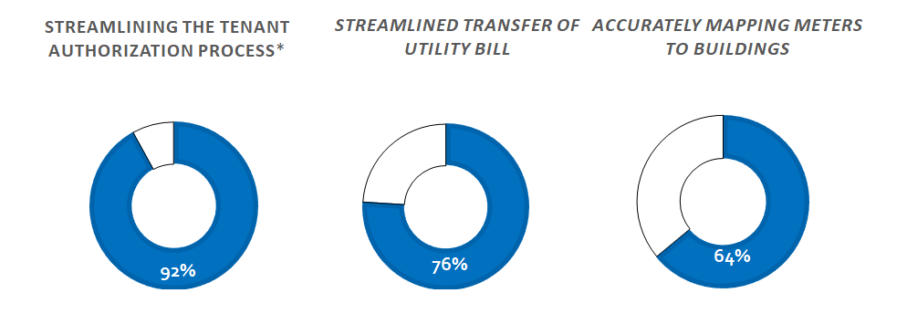
Figure 11: Best practices developed by Energy Data Accelerators partners

92% of the utility partners committed or were already providing streamlined tenants authorization for data access. Utilities are often paid by the tenants and the process to aggregate the data to the whole-building levels created privacy concerns and the process created to overcome this issue were cumbersome. Utilities agreed that providing an simple online solution to collect or waive the tenant consent need would facilitate the process of benchmarking.
76% provided streamlined transfer of utility bills to benchmarking tools or would be able to do so by 2017. Many utilities were not using Green button capabilities and the energy data was only available on paper or by pdf or required manual download and data entry to Portfolio Managers. Utilities concluded that the process of transferring data from one database to an other should be automated.
64% committed to accurately map meter to buildings. Utility meters are linked to account holders but not necessarily connected back to their physical address. This reality made the fact of gathering and aggregating data at the whole building level challenging. Utilities agreed that meters should have more accurate geo-spatial information to ensure they are linked to the right physical address to support benchmarking.
These findings were made possible through the collaboration of the utilities partner in the Energy Data Accelerators.The adoption of these best practices will lead to better customer services. These increase the opportunities for customer awareness that ultimately create more investment in energy efficiency.

H3 : increased energy efficiency

Benchmarking and Transparency ordinances improve building energy use.

Methodology
In exploring my final hypothesis, I will use Energystar score as a proxy for EUI and will analyse if changes in score are greater in cities after passing an ordinances. Better improvement of score would support the commonly accepted idea that ordinances create a consistency and transparency that lead to faster adoption of new energy efficiency measures and improve energy performance of the buildings.

Selection of the Dataset for analysis
There are currently 5 datasets that could be used to evaluate the impact of benchmarking ordinance.
The Costar database:
This database is the #1 reference in real estate to collect information about buildings characteristics. This private database is accessible only through paid membership. Costar just signed a partnership to include benchmarking info in its dataset for cities with benchmarking ordinances. It does not include energy data for buildings without benchmarking and transparency ordinance. Therefore it does not offer an option for a control group and cannot be used for this research

The National Council of Real Estate Investment Fiduciary:
This dataset was used by Resources For the Future (RFF) for their analysis of utility expenditure. This dataset is private and not currently accessible to our research center.
CBECS database :
While being an invaluable source of information about the US building stock, the CBECS does not track the same buildings survey after survey: it does not allow to track and measure improvement to the same buildings.
Building Performance Database :
This dataset comprise the data set in Portfolio Manager and additional private data. The Building Performance Database (BPD) is the nation's largest dataset of information about the energy-related characteristics of commercial and residential buildings.
The information is accessible in various aggregated comparisons created by the user. By using the online tool filtering capabilities, I will be able to establish some overall descriptive statistics about benchmarking ordinances.
Portfolio Manager Database:
This database is proprietary to the Environmental Protection agency.
This dataset contains buildings who chose to track energy performance for their own building management decision making as well as the data being reported for compliance with benchmarking. The dataset from Energystar has spatial heterogeinity across the united state. Additionally, the data collected by compliance have energy performance heterogeneity that should allow better comparison (Hsu 2014).
Portfolio manager is used by all the existing benchmarking ordinances.
I have introduce my research goals and the benefit to using their dataset for my analyses to the EPA and they have shown interest in its value. However, they currently will not provide access to the data, possibly because of the challenge the update to the metrics have been posing since August.

Energystar database.
Buildings that have ENERGY STAR score of 75 or higher are publicly listed in the ENERGYSTAR database. This dataset is downloadable.
It contains basic building characteristics and the year and score of each buildings.
This dataset contains over 34,000 buildings across the United States with score >75.The subset of commercial building includes 11,247 office buildings including medical offices and banks. This database is voluntary and include buildings that were certified ENERGYSTAR at least once between 1999 and 2017.
The database includes buildings in 1722 different cities.
2019 buildings are located in cities that currently have benchmarking ordinances. 949 buildings are in one of the first five cities that enacted benchmarking and transparency ordinances ( Austin, DC, Seattle, New York, San Franscisco).
Energystar score are calculated based on 13 different parameters including the real EUI and a predicted EUI calculated based on CBECS data. CBECS data is updated every 4-5 years and therefore the score are recalculated with each update This CBECS data is old and some cons. Energystar score is a good proxy for EUI change as the EUI is the only variables used to calculate a score that changes over time.
While energystar is calculated based on CBECS data, data from 2007 to 2017 are all base on the same CBECS survey from 2003. Therefore, the score stopped representing a quartile and all buildings who made improvement that reduced their energy use have seen their score rise.

Analyses to be conducted

Growth of the database
I will run statistical analysis to evaluate how ordinances impacted participation in Portfolio Manager. Figure 12 illustrates the current growth in participation and score improvement in the ENERGYSTAR database.

Figure 12: growth of the Energystar Database
Table 6 contains the values plotted on figure 12.

All | 2007 | 2008 | 2009 | 2010 | 2011 | 2012 | 2013 | 2014 | 2015 | 2016 | 2017
#bldgs | 860 | 1870 | 2509 | 3306 | 3188 | 4135 | 3909 | 3900 | 4211 | 4456 | 5217
Ave score | 84.2 | 84.8 | 84.7 | 85.1 | 85.2 | 85.2 | 85.2 | 85.0 | 85.6 | 86.4 | 86.7
Table 6: number of buildings and their average score per year since 2007 in ENERGYSTAR database
We can observe that the score kept improving over all except in 2014 when the score decreased slightly and the number of buildings benchmarking plateaued. The growth resumed the following year.
The dataset will be decouple between cities with ordinances and other to identify a correlation with the implementation of ordinances.
The same analysis was conducted for the subset of buildings located in New York, NY and Houston, TX. New York has the largest population in the US, Houston has the 4th largest population and is the largest city without an ordinance. The results are plotted in figure 13.

Figure 13: growth of ENERGYSTAR buildings in New York City and Houston.
We can observe that the number of buildings in the database increased, with a sharper slope in 2012 and again in 2014, 3 years after the first deadline of 2011. In Houston, the numbers of building joining the dataset increased at a slower pace than in New York and decreased in 2017.
The average score varied but increased over all in similar growth.
The buildings in Houston consistently have a better score than in New York on average.
This analysis will be conducted for all cities with benchmarking ordinances and the growth in participation due to the ordinance will be quantified.

Continuous benchmarking
Ordinances mandates annual benchmarking and the increase of continuous benchmarking due to compliance will be evaluated as compare to voluntary effort. The number of buildings continuously benchmarking in cities without benchmarking will be estimated and compared to cities with ordinances

Increase in score over time
The increase in energystar score after the first deadline of benchmarking will be evaluated for each cities with ordinances and will be compared to the natural increase in performance when the effort is only voluntary. The statistical significance of the difference will be evaluated.

Overall energy saved
Finally, the overall score improvement in the dataset linked to benchmarking will be correlated to estimated energy savings based on the public data set from New York.
Once the score increase created through benchmarking ordinance will be established, a detail analysis of actual energy saved in New York, NY and the estimated corresponding ENERGYSTAR score improvement will be established, it will be extrapolated to the national dataset to establish an estimated energy.

Deliverables

The findings of this research will establish quantified benefits that cities with existing benchmarking and transparency ordinances can utilize to justify their climate action plan. Additionally, it creates a roadmap for meeting climate action and energy efficiency goals for cities considering benchmarking and transparency ordinances.
While working on stakeholder engagement for the Better Building Energy Data Accelerator, we created a stakeholder engagement checklist to guide local government in reaching out to all the possible stakeholders and listing suggested topics to approach. We also developed case studies, 4 for the Consortium for Building Energy Innovation and 2 for the Better Building Solution Center. We collaborated with NREL and ICF on 3 other documents for the data access toolkit.
I am currently assisting the city of Pittsburgh in developing the most relevant pathway to complement the benchmarking ordinance. I have created a database of existing policies and will issue a policy recommendation memo before January 2018.
Finally, I have downloaded and cleaned up the dataset from ENERGYSTAR and will conduct multiple statistical analyses to quantify the impact of benchmarking ordinances.
The timeline for the delivery of these products is indicated in figure 13.
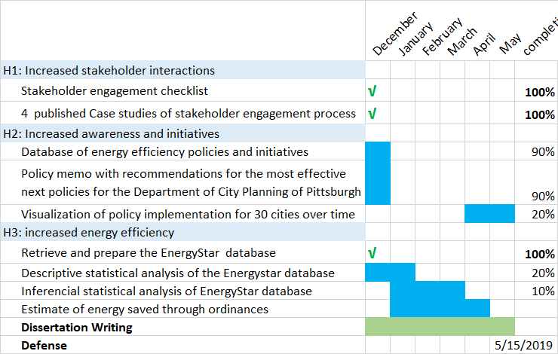
Figure 14: Research timeline of benchmarking ordinances impacts

References

Antonoff, Jayson, and Nicole BALLINGER. 2014. Seattle benchmarking process. https://cmu.app.box.com/file/36142095290.
Ballinger, Nicole. 2013. “Seattle’s Energy Benchmarking and Reporting Program.” Presentation]. Seattle : Seattle.Gov.
Bolduc, John. 2014. EDA Stakeholder call with Cambridge.
Burr, Andrew. 2012. “Energy DisclosureThe New Frontier For American Jobs.” Institute for Market Transformation.
City of New York. 2007. “PlaNYC, Building a Greener, Greater New York.” The City of New York.
———. 2018. “NYC Carbon Challenge_2018_Progress Report.Pdf.” http://www.nyc.gov/html/gbee/downloads/pdf/NYC%20Carbon%20Challenge_2018_Progress%20Report.pdf.
City of Pittsburgh. 2018. “606_PCAP_3_0_Draft-_9-26-17.Pdf.” http://apps.pittsburghpa.gov/redtail/images/606_PCAP_3_0_Draft-_9-26-17.pdf.
Coleman, Patrick, and Brian Kauffman. 2014. “TRACKING ENERGY TO TAKE ACTION:,” 28.
DOE. 2012. “Energy Intensity Indicators: Highlights | Department of Energy.” 2012. https://www.energy.gov/eere/analysis/energy-intensity-indicators-highlights.
———. 2015. “New York City Benchmarking and Transparency Policy Impact Evaluation Report,” 74.
Duer Balkind, Marshall. 2015. Interview about Stakeholder Engagement and Data access.
EIA. 2012. “Annual Energy Review 2011.” EIA.
———. 2018. “How Much Energy Is Consumed in U.S. Residential and Commercial Buildings? - FAQ - U.S. Energy Information Administration (EIA).” 2018. https://www.eia.gov/tools/faqs/faq.php?id=86&t=1.
EnergyStar. 2015. “List of Portfolio Manager Property Type, Definitions, and Use Details.” EPA. https://www.energystar.gov/sites/default/files/tools/Property_Use_Details_and_Definitions_20150210_508.pdf.
EPA. 2012. “Benchmarking and Energy Savings.” Portfolio Manager Data Trend. Environmental Protection Agency.
———. 2016. “Energy Star 2015 Snapshot - Measuring Progress in the Commercial and Industrial Buildings Sector - August 2016,” August, 28.
Faruqui, Ahmad, Sanem Sergici, and Ahmed Sharif. 2010. “The Impact of Informational Feedback on Energy Consumption—A Survey of the Experimental Evidence.” Energy, Demand Response Resources: the US and International Experience, 35 (4): 1598–1608. https://doi.org/10.1016/j.energy.2009.07.042.
Fuerst, Franz, and Patrick McAllister. 2009. “An Investigation of the Effect of Eco-Labeling on Office Occupancy Rates.” Journal of Sustainable Real Estate 1 (1): 49–64. https://doi.org/10.5555/jsre.1.1.wuk75p1017qhv214.
Greenworks Orlando. 2016. “Council Minutes GreenWorks BEWES Presentation-9-15-2016.” 2016. http://www.cityoforlando.net/cityclerk/wp-content/uploads/sites/12/2016/09/Council-Minutes-GreenWorks-BEWES-presentation-9-15-2016.pdf.
Hart. 2018. “Sharing-Data-to-Motivate-Action.Pdf.” 2018. https://www.imt.org/wp-content/uploads/2018/05/Sharing-Data-to-Motivate-Action.pdf.
Hawken. 2017. “Drawdown.” Drawdown. 2017. https://www.drawdown.org/.
Hsu, David. 2014. “Improving Energy Benchmarking with Self-Reported Data.” Building Research & Information 42 (5): 641–56. https://doi.org/10.1080/09613218.2014.887612.
Krukowski, Andrea. 2014. “Creating Value from Benchmarking: A Utility Perspective.” IMT.
Mazria, Ed. 2002. “About Us – Architecture 2030.” 2002. https://architecture2030.org/about/.
Mims, N., S. Schiller, E. Stuart, L. Schwartz, C. Kramer, and R. Faesy. 2017. “Evaluation of U.S. Building Energy Benchmarking and Transparency Programs: Attributes, Impacts, and Best Practices,” April. https://escholarship.org/uc/item/3170j728.
Monisha Shah. 2015. “Energy Data Accelerator Partners Workshop.” May.
NEEP. 2013. “Building Energy Rating and Disclosure Policies Update and Lessons From the Field.” 2013. https://neep.org/sites/default/files/resources/BER%20Supplement_FINAL%20DRAFT_2-25-13.pdf.
NEMA. 2017. “Energy Benchmarking Policies Lead to Installation of Energy-Saving Technologies - NEMA.” 2017. https://www.nema.org/news/Pages/Energy-Benchmarking-Policies-Lead-to-Installation-of-Energy-Saving-Technologies.aspx.
NMR group, Howard. 2012. “Statewide Benchmarking Process Evaluation,” 200.
Palmer, Karen, and Margaret Walls. 2014. “Can Benchmarking and Disclosure Laws Provide Incentives for Energy Efficiency Improvements in Commercial Buildings?” In Large Opportunities, Complex Challenges: Seizing the Energy Efficiency Opportunity in the Commercial Buildings Sector.
Pérez-Lombard, Luis, José Ortiz, Rocío González, and Ismael R. Maestre. 2009. “A Review of Benchmarking, Rating and Labelling Concepts within the Framework of Building Energy Certification Schemes.” Energy and Buildings 41 (3): 272–78. https://doi.org/10.1016/j.enbuild.2008.10.004.
Shah, Monisha, Andrew Burr, Andrew Schulte, Kristin Field-Macumber, Erica Cochran-Hameen, and Flore Marion. 2016. “DOE Voluntary Partnership Program with Utilities and Local Governments Supports the Design of New Data Access Solutions.” NREL/CP-6A20-66233. Washington, D.C.: American Council for an Energy-Efficient Economy (ACEEE). https://www.osti.gov/biblio/1324397.

DVGBC is now Greenbuild United

