Resource for Developmental Regulatory Genomics (RDRG)
Request for Bacterial Artificial Chromosome (BAC) Material

1) PI name:

2) Mailing address to which clones are to be sent:

3) Research award(s) to be enhanced by the material provided:
(in each case please list only the title of the grant, funding agency, and grant number)

4) BAC clones requested:

a) For all BACs identified from the BAC table (http://www.echinobase.org/Echinobase/bac_table/bac_table.php)
indicate the specific BAC name (e.g., Sp_142J11).

b) For all genomic BACs identified by library screening, indicate the BAC library (see available list of arrayed filters at http://www.echinobase.org/Echinobase/filters)
and the plate/well number of the clone (see below)

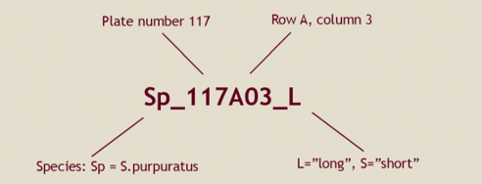

5) Requests for custom library screening or production of new recombinant BACs by the RDRG should be described here:

